**Experimento #1**

Learning rate warm up 0.001

Learning rate fine-tuning 0.001

Test set classification report after warmup:

precision recall f1-score support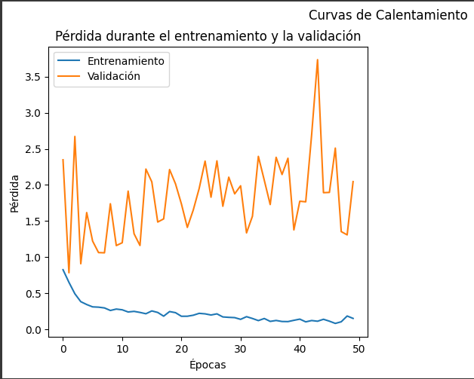

Clase 0 0.81 0.88 0.84 67

Clase 1 0.27 0.18 0.21 17

accuracy 0.74 84

macro avg 0.54 0.53 0.53 84

weighted avg 0.70 0.74 0.72 84

Test set AUC Score after warmup: 0.6312554872695347

11/11 [==============================] - 5s 495ms/step

Train set classification report after warmup:

precision recall f1-score support

Clase 0 0.89 0.98 0.93 265

Clase 1 0.87 0.56 0.68 70

accuracy 0.89 335

macro avg 0.88 0.77 0.81 335

weighted avg 0.89 0.89 0.88 335

Train set AUC Score after warmup: 0.8147169811320754

Test set classification report after fine-tuning:

precision recall f1-score support

Clase 0 0.85 0.61 0.71 67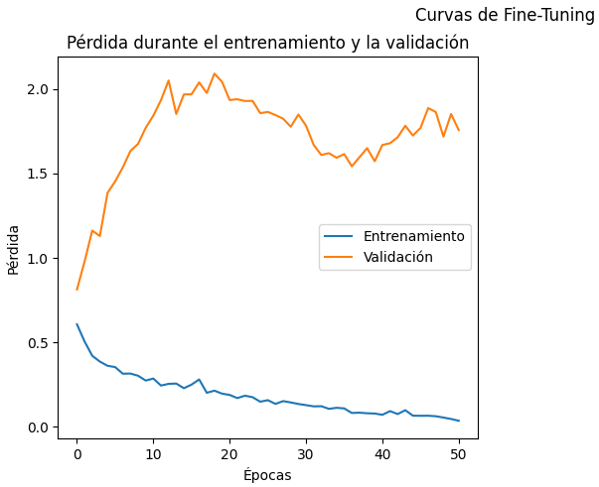

Clase 1 0.28 0.59 0.38 17

accuracy 0.61 84

macro avg 0.57 0.60 0.55 84

weighted avg 0.74 0.61 0.65 84

Test set AUC Score after fine-tuning: 0.5864793678665495

11/11 [==============================] - 3s 266ms/step

Train set classification report after fine-tuning:

precision recall f1-score support

Clase 0 0.85 0.59 0.69 265

Clase 1 0.28 0.60 0.38 70

accuracy 0.59 335

macro avg 0.56 0.59 0.54 335

weighted avg 0.73 0.59 0.63 335

Train set AUC Score after fine-tuning: 0.6750943396226416

**Experimento #2**

Learning rate warm up 0.0001

Learning rate fine-tuning 0.0001

Test set classification report after warmup:

precision recall f1-score support

Clase 0 0.79 0.85 0.82 67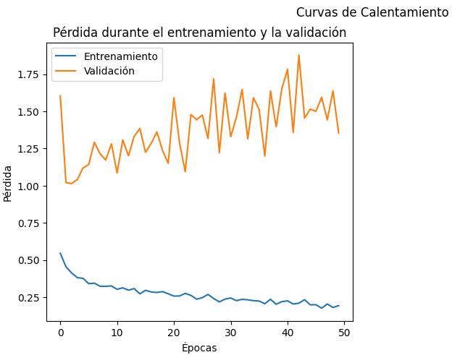

Clase 1 0.17 0.12 0.14 17

accuracy 0.70 84

macro avg 0.48 0.48 0.48 84

weighted avg 0.67 0.70 0.68 84

Test set AUC Score after warmup: 0.5425812115891133

11/11 [==============================] - 5s 479ms/step

Train set classification report after warmup:

precision recall f1-score support

Clase 0 0.87 0.93 0.90 265

Clase 1 0.65 0.49 0.56 70

accuracy 0.84 335

macro avg 0.76 0.71 0.73 335

weighted avg 0.83 0.84 0.83 335

Train set AUC Score after warmup: 0.7701886792452831

Test set classification report after fine-tuning:

precision recall f1-score support

Clase 0 0.80 0.99 0.88 67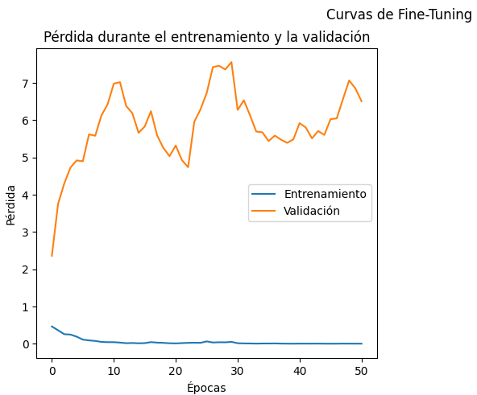

Clase 1 0.00 0.00 0.00 17

accuracy 0.79 84

macro avg 0.40 0.49 0.44 84

weighted avg 0.63 0.79 0.70 84

Test set AUC Score after fine-tuning: 0.5065847234416154

11/11 [==============================] - 2s 139ms/step

Train set classification report after fine-tuning:

precision recall f1-score support

Clase 0 0.80 0.98 0.88 265

Clase 1 0.55 0.09 0.15 70

accuracy 0.79 335

macro avg 0.67 0.53 0.52 335

weighted avg 0.75 0.79 0.73 335

Train set AUC Score after fine-tuning: 0.6528840970350405

**Experimento #3**

Learning rate warm up 0.01

Learning rate fine-tuning 0.001

Test set classification report after warmup:

precision recall f1-score support

Clase 0 0.80 0.97 0.88 67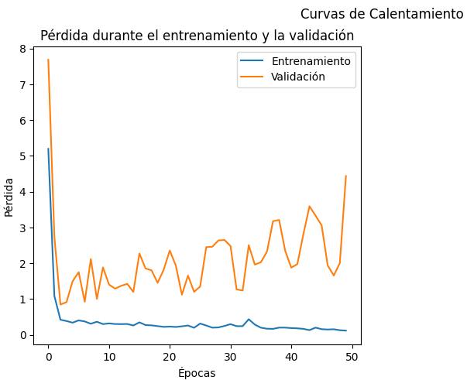

Clase 1 0.33 0.06 0.10 17

accuracy 0.79 84

macro avg 0.57 0.51 0.49 84

weighted avg 0.71 0.79 0.72 84

Test set AUC Score after warmup: 0.6031606672519755

11/11 [==============================] - 8s 679ms/step

Train set classification report after warmup:

precision recall f1-score support

Clase 0 0.84 0.98 0.91 265

Clase 1 0.81 0.30 0.44 70

accuracy 0.84 335

macro avg 0.82 0.64 0.67 335

weighted avg 0.83 0.84 0.81 335

Train set AUC Score after warmup: 0.7732075471698112

Test set classification report after fine-tuning:

precision recall f1-score support

Clase 0 0.67 0.18 0.28 67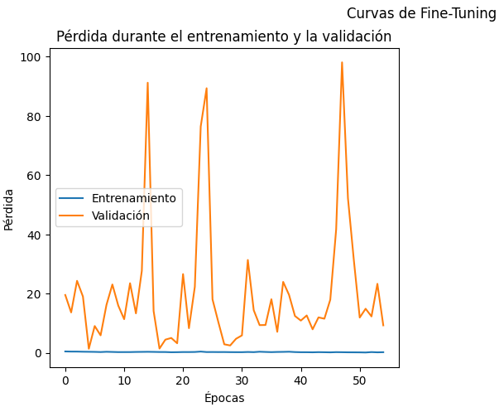

Clase 1 0.17 0.65 0.27 17

accuracy 0.27 84

macro avg 0.42 0.41 0.27 84

weighted avg 0.57 0.27 0.28 84

Test set AUC Score after fine-tuning: 0.39508340649692714

11/11 [==============================] - 2s 143ms/step

Train set classification report after fine-tuning:

precision recall f1-score support

Clase 0 0.75 0.10 0.18 265

Clase 1 0.20 0.87 0.33 70

accuracy 0.26 335

macro avg 0.48 0.49 0.26 335

weighted avg 0.64 0.26 0.21 335

Train set AUC Score after fine-tuning: 0.41547169811320755

**Experimento #4**

Learning rate warm up 0.01

Learning rate fine-tuning 0.00001

Test set classification report after warmup:

precision recall f1-score support

Clase 0 0.80 0.94 0.86 67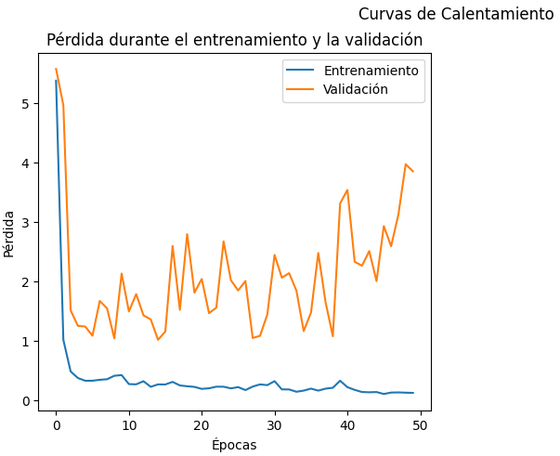

Clase 1 0.20 0.06 0.09 17

accuracy 0.76 84

macro avg 0.50 0.50 0.48 84

weighted avg 0.68 0.76 0.71 84

Test set AUC Score after warmup: 0.5873573309920983

11/11 [==============================] - 8s 766ms/step

Train set classification report after warmup:

precision recall f1-score support

Clase 0 0.86 0.99 0.92 265

Clase 1 0.90 0.39 0.54 70

accuracy 0.86 335

macro avg 0.88 0.69 0.73 335

weighted avg 0.87 0.86 0.84 335

Train set AUC Score after warmup: 0.7911051212938006

Test set classification report after fine-tuning:

precision recall f1-score support

Clase 0 0.84 0.76 0.80 67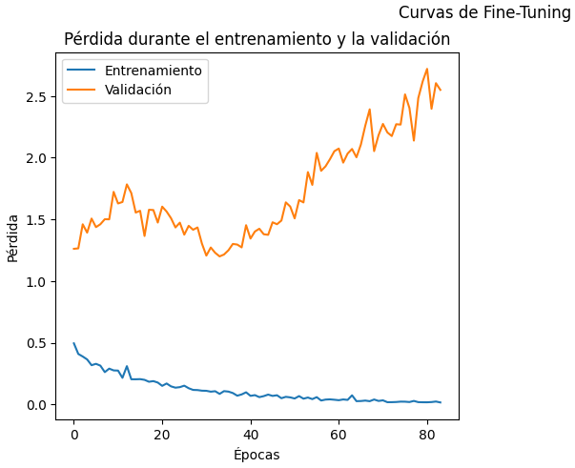

Clase 1 0.30 0.41 0.35 17

accuracy 0.69 84

macro avg 0.57 0.59 0.57 84

weighted avg 0.73 0.69 0.71 84

Test set AUC Score after fine-tuning: 0.5794556628621599

11/11 [==============================] - 2s 172ms/step

Train set classification report after fine-tuning:

precision recall f1-score support

Clase 0 0.88 0.88 0.88 265

Clase 1 0.54 0.56 0.55 70

accuracy 0.81 335

macro avg 0.71 0.72 0.71 335

weighted avg 0.81 0.81 0.81 335

Train set AUC Score after fine-tuning: 0.7497035040431267

**Experimento #5**

Learning rate warm up 0.001

Learning rate fine-tuning 0.000001

Test set classification report after warmup:

precision recall f1-score support

Clase 0 0.83 0.90 0.86 67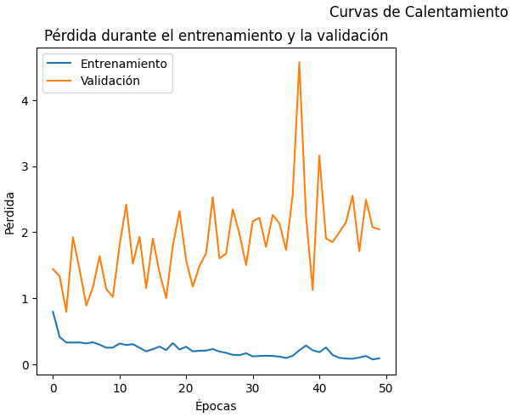

Clase 1 0.42 0.29 0.34 17

accuracy 0.77 84

macro avg 0.62 0.59 0.60 84

weighted avg 0.75 0.77 0.76 84

Test set AUC Score after warmup: 0.6215978928884986

11/11 [==============================] - 5s 454ms/step

Train set classification report after warmup:

precision recall f1-score support

Clase 0 0.88 0.97 0.92 265

Clase 1 0.80 0.51 0.63 70

accuracy 0.87 335

macro avg 0.84 0.74 0.77 335

weighted avg 0.87 0.87 0.86 335

Train set AUC Score after warmup: 0.8073315363881403

Test set classification report after fine-tuning:

precision recall f1-score support

Clase 0 0.86 0.45 0.59 67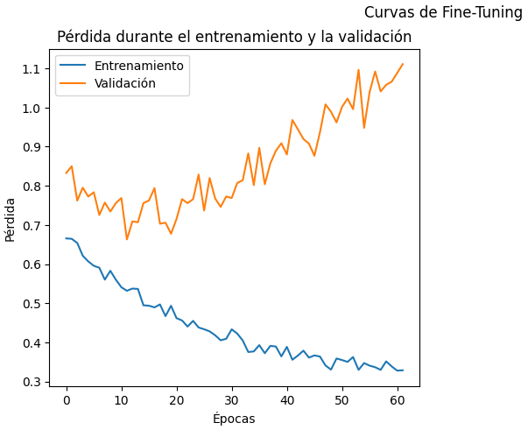

Clase 1 0.24 0.71 0.36 17

accuracy 0.50 84

macro avg 0.55 0.58 0.48 84

weighted avg 0.73 0.50 0.54 84

Test set AUC Score after fine-tuning: 0.655838454784899

11/11 [==============================] - 2s 172ms/step

Train set classification report after fine-tuning:

precision recall f1-score support

Clase 0 0.89 0.48 0.62 265

Clase 1 0.28 0.77 0.41 70

accuracy 0.54 335

macro avg 0.58 0.63 0.52 335

weighted avg 0.76 0.54 0.58 335

Train set AUC Score after fine-tuning: 0.7019407008086254

**Experimento #6**

Learning rate warm up 0.0001

Learning rate fine-tuning 0.0000001

Test set classification report after warmup:

precision recall f1-score support

Clase 0 0.79 0.90 0.84 67

Clase 1 0.12 0.06 0.08 17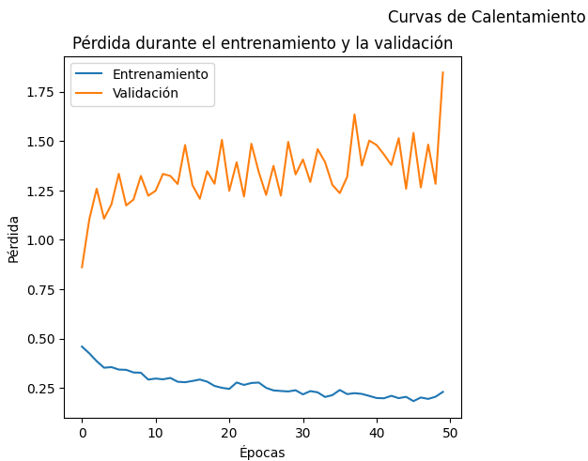

accuracy 0.73 84

macro avg 0.46 0.48 0.46 84

weighted avg 0.65 0.73 0.69 84

Test set AUC Score after warmup: 0.5899912203687444

11/11 [==============================] - 6s 583ms/step

Train set classification report after warmup:

precision recall f1-score support

Clase 0 0.85 0.95 0.90 265

Clase 1 0.67 0.34 0.45 70

accuracy 0.83 335

macro avg 0.76 0.65 0.67 335

weighted avg 0.81 0.83 0.80 335

Train set AUC Score after warmup: 0.7734770889487871

Test set classification report after fine-tuning:

precision recall f1-score support

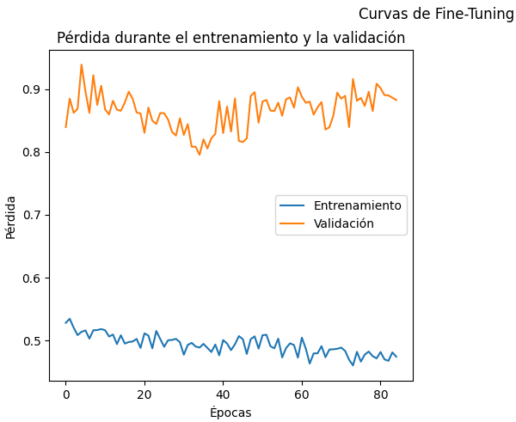

Clase 0 0.81 0.97 0.88 67

Clase 1 0.50 0.12 0.19 17

accuracy 0.80 84

macro avg 0.66 0.54 0.54 84

weighted avg 0.75 0.80 0.74 84

Test set AUC Score after fine-tuning: 0.4863915715539947

11/11 [==============================] - 3s 198ms/step

Train set classification report after fine-tuning:

precision recall f1-score support

Clase 0 0.79 0.92 0.85 265

Clase 1 0.16 0.06 0.08 70

accuracy 0.74 335

macro avg 0.47 0.49 0.47 335

weighted avg 0.66 0.74 0.69 335

Train set AUC Score after fine-tuning: 0.5525067385444744

**Experimento #7**

Learning rate warm up 0.001

Learning rate fine-tuning 0.000001

Test set classification report after warmup:

precision recall f1-score support

Clase 0 0.80 0.85 0.83 67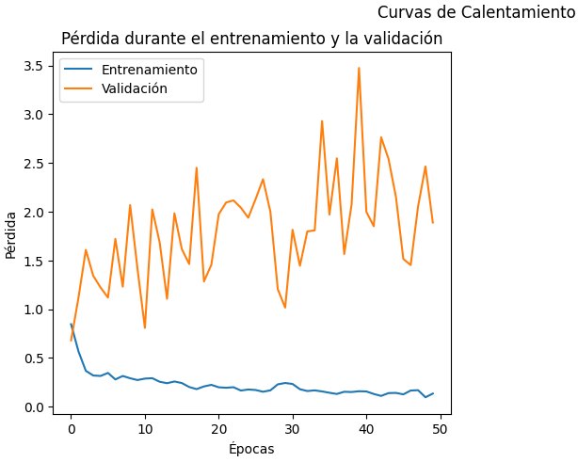

Clase 1 0.23 0.18 0.20 17

accuracy 0.71 84

macro avg 0.52 0.51 0.51 84

weighted avg 0.69 0.71 0.70 84

Test set AUC Score after warmup: 0.5741878841088675

11/11 [==============================] - 8s 767ms/step

Train set classification report after warmup:

precision recall f1-score support

Clase 0 0.89 0.96 0.92 265

Clase 1 0.78 0.54 0.64 70

accuracy 0.87 335

macro avg 0.83 0.75 0.78 335

weighted avg 0.86 0.87 0.86 335

Train set AUC Score after warmup: 0.8074932614555256

Test set classification report after fine-tuning:

precision recall f1-score support

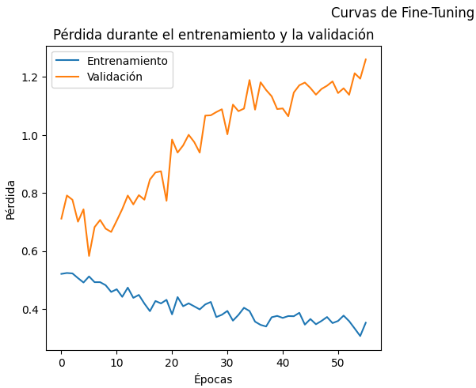

Clase 0 1.00 0.06 0.11 67

Clase 1 0.21 1.00 0.35 17

accuracy 0.25 84

macro avg 0.61 0.53 0.23 84

weighted avg 0.84 0.25 0.16 84

Test set AUC Score after fine-tuning: 0.5513608428446005

11/11 [==============================] - 2s 198ms/step

Train set classification report after fine-tuning:

precision recall f1-score support

Clase 0 0.83 0.07 0.13 265

Clase 1 0.21 0.94 0.35 70

accuracy 0.25 335

macro avg 0.52 0.51 0.24 335

weighted avg 0.70 0.25 0.18 335

Train set AUC Score after fine-tuning: 0.6481401617250674

**Experimento #8**

Learning rate warm up 0.0001

Learning rate fine-tuning 0.00000001

Test set classification report after warmup:

precision recall f1-score support

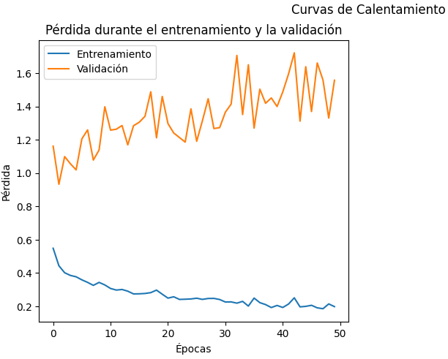

Clase 0 0.80 0.90 0.85 67

Clase 1 0.22 0.12 0.15 17

accuracy 0.74 84

macro avg 0.51 0.51 0.50 84

weighted avg 0.68 0.74 0.71 84

Test set AUC Score after warmup: 0.6084284460052678

11/11 [==============================] - 7s 643ms/step

Train set classification report after warmup:

precision recall f1-score support

Clase 0 0.85 0.95 0.90 265

Clase 1 0.67 0.37 0.48 70

accuracy 0.83 335

macro avg 0.76 0.66 0.69 335

weighted avg 0.81 0.83 0.81 335

Train set AUC Score after warmup: 0.7757412398921832

Test set classification report after fine-tuning:

precision recall f1-score support

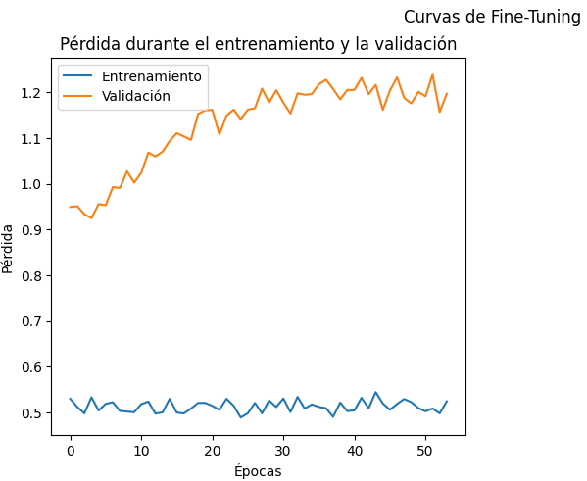

Clase 0 0.80 0.99 0.88 67

Clase 1 0.00 0.00 0.00 17

accuracy 0.79 84

macro avg 0.40 0.49 0.44 84

weighted avg 0.63 0.79 0.70 84

Test set AUC Score after fine-tuning: 0.48375768217734855

11/11 [==============================] - 2s 140ms/step

Train set classification report after fine-tuning:

precision recall f1-score support

Clase 0 0.80 0.98 0.88 265

Clase 1 0.54 0.10 0.17 70

accuracy 0.79 335

macro avg 0.67 0.54 0.53 335

weighted avg 0.75 0.79 0.73 335

Train set AUC Score after fine-tuning: 0.645498652291105

**Experimento #9**

Learning rate warm up 0.00001

Learning rate fine-tuning 0.0001

Test set classification report after warmup:

precision recall f1-score support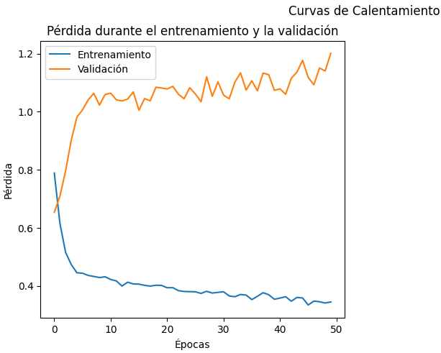

Clase 0 0.80 0.88 0.84 67

Clase 1 0.20 0.12 0.15 17

accuracy 0.73 84

macro avg 0.50 0.50 0.49 84

weighted avg 0.68 0.73 0.70 84

Test set AUC Score after warmup: 0.585601404741001

11/11 [==============================] - 1s 125ms/step

Train set classification report after warmup:

precision recall f1-score support

Clase 0 0.83 0.94 0.88 265

Clase 1 0.53 0.26 0.35 70

accuracy 0.80 335

macro avg 0.68 0.60 0.61 335

weighted avg 0.77 0.80 0.77 335

Train set AUC Score after warmup: 0.6754177897574124

Test set classification report after fine-tuning:

precision recall f1-score support

Clase 0 0.80 1.00 0.89 67

Clase 1 0.00 0.00 0.00 17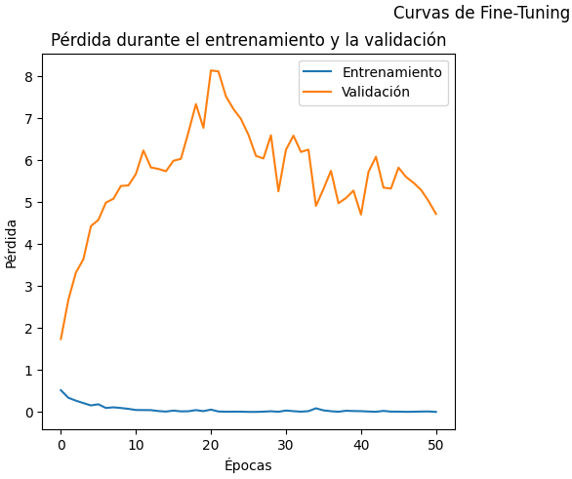

accuracy 0.80 84

macro avg 0.40 0.50 0.44 84

weighted avg 0.64 0.80 0.71 84

Test set AUC Score after fine-tuning: 0.510974539069359

11/11 [==============================] - 1s 101ms/step

Train set classification report after fine-tuning:

precision recall f1-score support

Clase 0 0.80 0.98 0.88 265

Clase 1 0.50 0.06 0.10 70

accuracy 0.79 335

macro avg 0.65 0.52 0.49 335

weighted avg 0.74 0.79 0.72 335

Train set AUC Score after fine-tuning: 0.5890026954177897

**Experimento #9**

Learning rate warm up 0.001

Learning rate fine-tuning 0.000001

Test set classification report after warmup:

precision recall f1-score support

Clase 0 0.80 0.94 0.86 67

Clase 1 0.20 0.06 0.09 17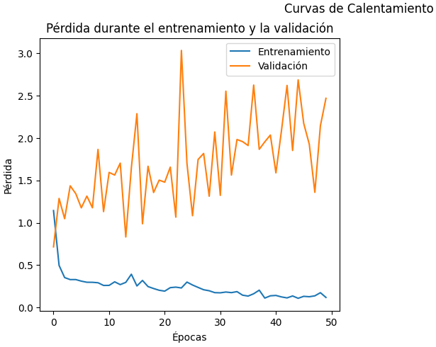

accuracy 0.76 84

macro avg 0.50 0.50 0.48 84

weighted avg 0.68 0.76 0.71 84

Test set AUC Score after warmup: 0.5961369622475856

11/11 [==============================] - 1s 134ms/step

Train set classification report after warmup:

precision recall f1-score support

Clase 0 0.86 0.98 0.92 265

Clase 1 0.88 0.41 0.56 70

accuracy 0.87 335

macro avg 0.87 0.70 0.74 335

weighted avg 0.87 0.87 0.85 335

Train set AUC Score after warmup: 0.8048517520215634

Test set classification report after fine-tuning:

precision recall f1-score support

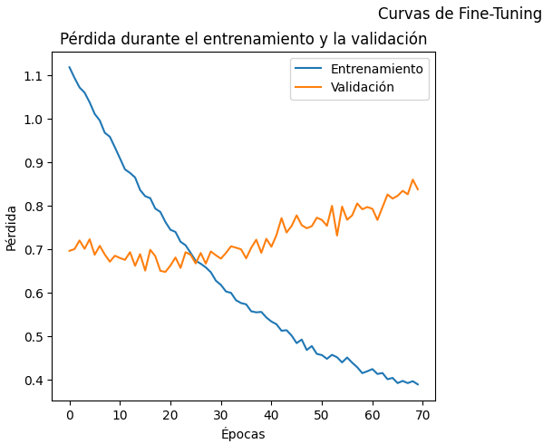

Clase 0 0.83 0.07 0.14 67

Clase 1 0.21 0.94 0.34 17

accuracy 0.25 84

macro avg 0.52 0.51 0.24 84

weighted avg 0.71 0.25 0.18 84

Test set AUC Score after fine-tuning: 0.49692712906057945

11/11 [==============================] - 1s 111ms/step

Train set classification report after fine-tuning:

precision recall f1-score support

Clase 0 1.00 0.03 0.05 265

Clase 1 0.21 1.00 0.35 70

accuracy 0.23 335

macro avg 0.61 0.51 0.20 335

weighted avg 0.84 0.23 0.11 335

Train set AUC Score after fine-tuning: 0.6394070080862534

**Experimento 10**

Learning rate warm up 0.001

Learning rate fine-tuning 0.000001

3/3 [==============================] - 2s 102ms/step

Test set classification report after fine-tuning:

precision recall f1-score support

Clase 0 0.83 0.07 0.14 67

Clase 1 0.21 0.94 0.34 17

accuracy 0.25 84

macro avg 0.52 0.51 0.24 84

weighted avg 0.71 0.25 0.18 84

Test set AUC Score after fine-tuning: 0.49692712906057945

11/11 [==============================] - 1s 111ms/step

Train set classification report after fine-tuning:

precision recall f1-score support

Clase 0 1.00 0.03 0.05 265

Clase 1 0.21 1.00 0.35 70

accuracy 0.23 335

macro avg 0.61 0.51 0.20 335

weighted avg 0.84 0.23 0.11 335

Train set AUC Score after fine-tuning: 0.6394070080862534

Realizar la matriz de confusión para mirar los errores. quizas en 3 semanas.

cual es la metrica mas importante y por que

en que se diferencia esto del paper